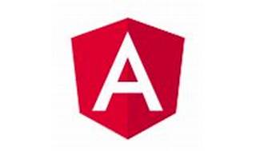

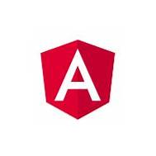

Explore

**Angular NativeScript** is an open-source framework that allows you to build truly native mobile apps using JavaScript, while leveraging your existing Angular skills. [It provides a native UI and performance on both iOS and Android platforms1](https://blog.angular.io/apps-that-work-natively-on-the-web-and-mobile-9b26852495e7).

Here are **five free reference links** where you can learn more about Angular NativeScript:

1. [**Apps That Work Natively on the Web and Mobile**](https://blog.angular.io/apps-that-work-natively-on-the-web-and-mobile-9b26852495e7): This article explains how to build web and mobile apps with Angular and NativeScript, sharing code between the two platforms[1](https://blog.angular.io/apps-that-work-natively-on-the-web-and-mobile-9b26852495e7).
2. [**Build Truly Native Mobile Apps with Angular**](https://old.nativescript.org/nativescript-is-how-you-build-native-mobile-apps-with-angular/): Learn how to combine NativeScript and Angular to create native iOS, Android, and web apps from a single codebase[2](https://old.nativescript.org/nativescript-is-how-you-build-native-mobile-apps-with-angular/).
3. [**Angular Tutorials**](https://angular.io/tutorial): The official Angular tutorial provides step-by-step guidance for building applications with Angular, including fundamentals, components, data binding, and more[3](https://angular.io/tutorial).
4. [**Free Angular Tutorial - Try Angular v4**](https://www.udemy.com/course/try-angular/): Explore the basics of Angular, from web apps to mobile apps, in this free Udemy course[4](https://www.udemy.com/course/try-angular/).
5. [**Getting Started with Angular: A Mobile Developer’s Approach**](https://www.thisdot.co/blog/getting-started-with-angular-a-mobile-developers-approach): Gain insights into Angular from a mobile developer’s perspective and kickstart your learning journey[5](https://www.thisdot.co/blog/getting-started-with-angular-a-mobile-developers-approach).

Happy coding! 🚀📱